

MARANDA 2025 KCSE PREDICTION
EXPECTED EXAM 1
HOME SCIENCE
441/1
PAPER 1 (Theory)
TIME: 2½ HOURS

NAME……………………………………………………………………………………..
SCHOOL……………………………………………… SIGN………………………..
INDEX NO……………………………………………. ADM NO……………………

Kenya Certificate of Secondary Education.

INSTRUCTIONS TO CANDIDATES
- Write your name and index number in the spaces provided above.
- Sign and write the date in the examination spaces provided above
- This paper consists of three sections: A, B and C.
- Answer all questions in section A and B and any two from section C.
- Answers to all the questions must be written in the spaces provided.
- Candidates should answer the questions in English.

FOR EXAMINER’S USE ONLY
Section | Question | Maximum  Score | Candidate’s  Score
A | 1-20 | 40
B | 21 | 20
C | 22-24 | 40
Total score |  | 100

SECTION A (40 MARKS)
Answer all questions in this section
- State two uses of eggs in flour mixtures. (2 marks)
......................................................................................................................
......................................................................................................................
......................................................................................................................

- Give two ways of preventing skin diseases. (2 marks)
......................................................................................................................
......................................................................................................................
......................................................................................................................

- State two disadvantages of traditional house designs. (2 marks)
......................................................................................................................
......................................................................................................................
......................................................................................................................

- State two qualities of travel wear. (2 marks)
......................................................................................................................
......................................................................................................................

- Give the importance of calcium in expectant women. (2 marks)
......................................................................................................................
......................................................................................................................
......................................................................................................................

- Give two disadvantages of credit cards. (2 marks)
......................................................................................................................
......................................................................................................................

- Give two reasons why babies fed on infant formula may suffer from diarrhea. (2 marks)
......................................................................................................................
......................................................................................................................
......................................................................................................................

- Identify two precautions to take when cleaning glass utensils. (2 marks)
......................................................................................................................
......................................................................................................................
......................................................................................................................

- State two advantages of convenience foods. (2 marks)
......................................................................................................................
......................................................................................................................
......................................................................................................................

- Define ventilation. (1 mark)
......................................................................................................................
......................................................................................................................
......................................................................................................................

- State two reasons for ironing clothes (2 marks)
......................................................................................................................
......................................................................................................................
......................................................................................................................

- Mention two advantages of starching house hold articles. (2 marks)
......................................................................................................................
......................................................................................................................
......................................................................................................................

- Name two vaccines that are given to a baby immediately after birth. (2 marks)
......................................................................................................................
......................................................................................................................

- Mention three areas/centres of work that make up the work triangle. (3 marks)
......................................................................................................................
......................................................................................................................
......................................................................................................................

- Suggest two reasons for cleaning paraffin tank of a hurricane lamp occasionally. (2 marks)
......................................................................................................................
......................................................................................................................
......................................................................................................................

- Differentiate between antiseptic liquid and disinfectant. (2 marks)
......................................................................................................................
......................................................................................................................
......................................................................................................................
......................................................................................................................

- Give two examples of self-neatening seams. (2 marks)
......................................................................................................................
......................................................................................................................
......................................................................................................................

- State two reasons for including fruit salad in a meal. (2 marks)
......................................................................................................................
......................................................................................................................
......................................................................................................................

- Give two uses of temporary stitches. (2 marks)
......................................................................................................................
......................................................................................................................
......................................................................................................................

- List two points to consider when selecting a thimble. (2 marks)
......................................................................................................................
......................................................................................................................

SECTION B (Compulsory)
- You have been assigned some household chores by your mother.
Describe the procedure of carrying out the following tasks.
- Making muddy contaminated water safe for drinking without using chlorine and storing it.
(8 marks)
- Dry cleaning and finishing polyester tie. (6 marks)
- Cleaning a melamine cup. (6 marks)

SECTION C (40 Marks)
Answer any TWO questions from this section in the space provided.
- a) State three laundry work processes that are harmful to woolen fibres and in each case state the harm caused. (6 marks)
b) Give the meaning of the following care symbols. (2 marks)
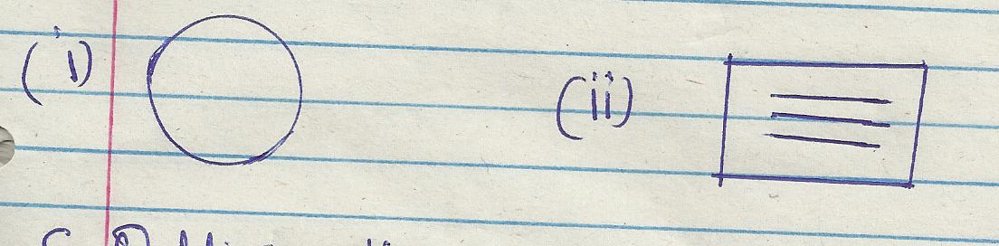
c) Outline the procedure of cleaning a kitchen refuse bin. (6 marks)
- Suggest five factors to consider when shopping for goods and services. (6 marks)

- a) Explain five considerations to make when furnishing a sitting room. (5 marks)
b) Explain three nutritional needs of an adolescent. (6 marks)
c) Explain five preparations to make on a fabric before cutting out. (5 marks)

d) Complete the following diagram on the classification of man made textile fibre.(4 marks)
(Indicate what the number given stands for)

Man made fibres

1
Synthetic fibres

Nylon
polyester
2
viscose
rayon
4

3
4

- a) State four ways of misusing medicine. (4 marks)
b) Giving reasons in each case, explain three changes that take place in dough during the frying of mandazi. (6 marks)
c) With the aid of two labeled diagrams, describe how to make an overlaid seam. (7 marks)
d) Name three nutritional disorders associated with lifestyle. (3marks)

